|  |  |
| --- | --- |
| **Practicum Case** |  |
| COMP6708  Object Oriented Programming |
| **Computer Science** | **O221-COMP6708-RV01-01** |
| ***Valid on*** *Odd Semester Year 2021/2022* | **Revision 00** |

## Learning Outcomes

* The main features of OOP
* A program using additional features of OOP

## Topic

* Introduction to Java Programming

## Subtopics

* Arithmetic operator
* Data Type
* Logical Operator
* Input and Output
* Selection and Repetition

## Soal

*Case*

**BlueJack JP Table**

**Bluejack JP Table** is a basic table whose purpose solely as a helping tool for early Java programmers. You, who happens to be an adept user of Java Programming, are asked to make a simple table consisting of **introduction to Java basics**, such as its **data types**, **arithmetics operations**, and **basic math logic**.

* In the beginning, the program will show the title

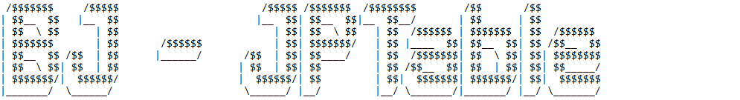

* The program will consist of 2 menus:

1. Start The Simulation!!
2. Close App

* The program will ask the user to input choose menu which must be **inputted with 1** or **2**

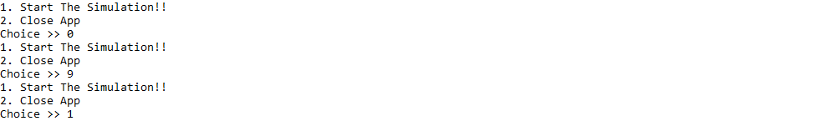

* If the user input 1, then:
* The program will ask the user to input:
* **First number**, which must be **between** **1 – 100** (**inclusive**)
* **Second number**, which must be **between** **1 – 100** (**inclusive**)

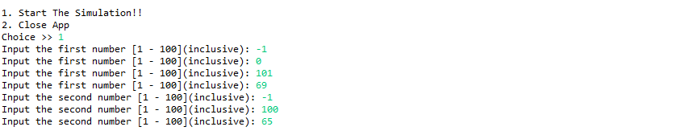

* After fulfilling all validation, the program will display:
* Table consisting of basic Java data types

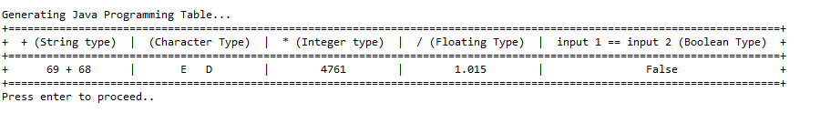

* Table consisting of basic arithmetic operation

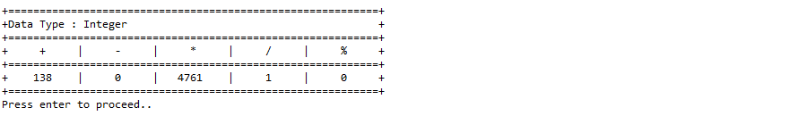

* After that, the program will simulate the boolean value that consists of the following process:
* Ask the user to input 2 boolean values, which must be **between true** and **false** (**using scan.nextBoolean()**)

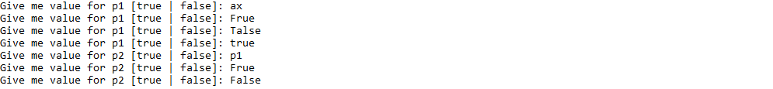

* Display a logical table based oninputted values

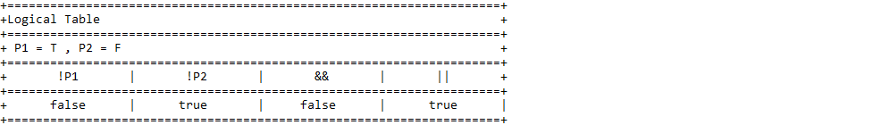

* Finally, the program will return to the menu
* If the user input 2, then:
* Display words of gratitude



* The program will be closed

**Please ask your teaching assistant if there are any related questions.**